FOR IMMEDIATE RELEASE
Contact: Miranda Blunt
Tel. 847-612-3230
Email: press@indiewed.com
Date: 07/15/2015
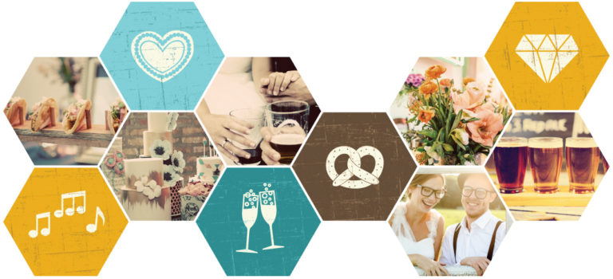
WEDTOBERFEST CHICAGO: BUBBLES & BREW
A new kind of wedding show for craft beer lovers
Wedtoberfest is a new, unconvential wedding show for craft beer lovers that mixes the joy of wedding planning with the fun of a beer festival. In addition to the barley and hops, Wedtoberfest will feature a curated selection of the very best wedding vendors and artisans in Chicagoland. These handpicked small businesses can show off their products and services in a casual, no-pressure environment. Couples will sample delicious food and drinks and soak up Pinterest-worthy inspiration while unwinding to some amazing DJs and live music.
It all happens on Thursday, September 17th, 2015 from 5:30-8:30 pm at Studio Manarchy, 656 West Hubbard, Chicago. Wedtoberfest tickets are $15/person and $25/couple in advance online. Attendees will receive a keepsake tasting glass and tickets for beverage flights and pints from the featured breweries. There will be plenty to see and do even if you aren’t a beer lover, including a selection of bubbly drinks “beyond the brew”.
This event caters to the modern couple that appreciates craft drinks and eats and wants to create a distinctive wedding experience. Wedtoberfest shatters the image of the typical, fussy bridal show and lets both brides and grooms have their cake, beer, and wedding planning too!

About Wedtoberfest
Wedtoberfest is a joint collaboration between Kelly Horvath from Indie Wed, the country’s longest running independent wedding show, and Chicago event planner Carlene Smith of Naturally Yours Events. Together Carlene and Kelly have created an event to get couples (including the guys) together for a night of wedding planning fun - with a beer in hand! To learn more visit: http://wedtoberfestchicago.com

